**Accessing VelocityEHS SDS Database:**

1.a) Visit the EHS Webpage – Click SDS section on HR Solutions.

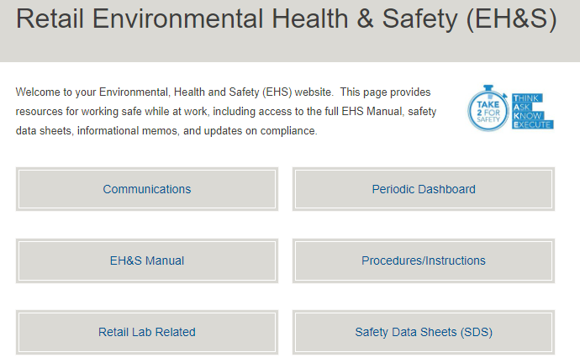

Or alternatively

1.b) Click directly on the [VelocityEHS SDS Database Link](https://eur01.safelinks.protection.outlook.com/?url=https%3A%2F%2Fchemmanagement.ehs.com%2F9%2F881befc5-4d1f-409e-a273-e2c3c3227cc4&data=04%7C01%7CMOlberding%40luxotticaretail.com%7C932d0a07247f4c28ab7d08da19b60ff3%7Cc7d1a8f705464a0c8cf53ddaebf97d51%7C0%7C0%7C637850566998074959%7CUnknown%7CTWFpbGZsb3d8eyJWIjoiMC4wLjAwMDAiLCJQIjoiV2luMzIiLCJBTiI6Ik1haWwiLCJXVCI6Mn0%3D%7C3000&sdata=MlbVlGtCVqlWc9mbimpI3VrStdGr0UU0ueoHrwA2H7A%3D&reserved=0):

[https://chemmanagement.ehs.com/9/881befc5-4d1f-409e-a273-e2c3c3227cc4](https://eur01.safelinks.protection.outlook.com/?url=https%3A%2F%2Fchemmanagement.ehs.com%2F9%2F881befc5-4d1f-409e-a273-e2c3c3227cc4&data=05%7C01%7CDavide.Minuzzo%40luxottica.com%7Cfc655b3333994c8a0ad008da64f4ff2c%7Cc7d1a8f705464a0c8cf53ddaebf97d51%7C0%7C0%7C637933300672114491%7CUnknown%7CTWFpbGZsb3d8eyJWIjoiMC4wLjAwMDAiLCJQIjoiV2luMzIiLCJBTiI6Ik1haWwiLCJXVCI6Mn0%3D%7C3000%7C%7C%7C&sdata=tJxU7q%2FXnPU1sCaRYHy9XvYcCCaNX5wyYpIocQSUGJQ%3D&reserved=0)

(A link is also available on your Brand webpage. Contact your Operations team for help in locating as needed.)

**Searching for SDS**

Once you are on the website, there are 2 ways to search for your SDS.

1. Search within our dedicated database **(eBinder)**.

This is more direct as it only looks through chemicals that have been previously approved for use by EssilorLuxottica.

1. Search the entire VelocityEHS SDS website (**MSDSOnline**).

This search allows you to look for any SDS, any product.

**TIP:** You can search using only part of a chemical name or by manufacturer. This is helpful if you are not sure how to spell something or the material may have multiple naming conventions.

**Option 1: eBinder Search (recommended)**

1. Search for your product by entering the research text in the below example search bar:

* Research text can be any of following: PRODUCT NAME; MANUFACTORER, PRODUCT CODE, CAS NUMBER, SYNONYMS, SUPPLIER



1. Click the GREEN ICON next to the product name. This will open the SDS for viewing and printing as need.

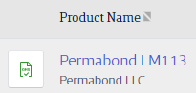

**Options 2: MSDSonline Menu Search**

(What to do if the product you are looking for is not found in the eBinder?)

**Step 1:** Access the MENU:



**Step 2:** Search for your product by entering the name in the following section:



If the SDS for your product still cannot be found, email [RetailSafety@luxotticaretail.com](mailto:RetailSafety@luxotticaretail.com) for assistance. Be sure to include the full material name and manufacturer name of the product you are looking for.